Globalization
Your shirt was made in Mexico and your shoes in China. Your CD player comes from Japan. You can travel to Moscow and eat a Big Mac there and you can watch an American film in Rome. Today goods are made and sold all over the world, thanks to globalization.
Globalization lets countries move closer to each other. People, companies and organizations in different countries can live and work together. We can exchange goods , money and ideas faster and cheaper than ever before. Modern communication and technology, like the Internet, cell phones or satellite TV help us in our daily lives.
Globalization is growing quickly. A German company can produce cars in Argentina and then sell them in the United States. A businessman in Great Britain can buy a part of a company in Indonesia on one day and sell parts of another business in China the next, thanks to globalization. Fast food companies open shops around the world almost every day.
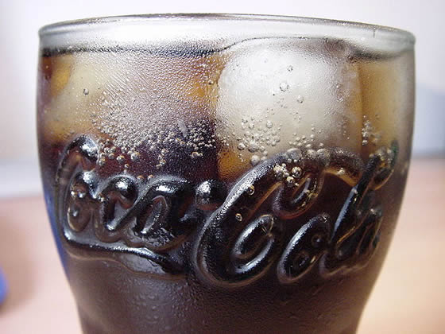

Coca Cola - A symbol of globalization

History of Globalization
Globalization is not new. For thousands of years people have been trading goods and travelling across great distances. During the Middle Ages, merchants travelled along the Silk Road, which connected Europe and China.
The modern age of globalization started with the Industrial Revolution at the end of the 18th century. New machines were able to produce cheaper goods. Trains and steam-powered boats transported products farther and faster.
Since 1980, globalization has been moving at a faster pace. Today it is easier for companies to work in other countries. The Internet gives them the chance of reaching more customers around the world. Teleworkers work for firms that may be far away.
However , there is a growing debate over globalization. Governments are in favour of globalization because the economy can grow. Other people are not so sure that there are only advantages. Here are some arguments from both sides:

Good sides
- Globalization lets countries do what they can do best. If, for example, you buy cheap steel from another country you don’t have to make your own steel. You can focus on computers or other things.
- Globalization gives you a larger market. You can sell more goods and make more money. You can create more jobs.
- Consumers also profit from globalization. Products become cheaper and you can get new goods more quickly.

Bad sides
- Globalization causes unemployment in industrialized countries because firms move their factories to places where they can get cheaper workers.
- Globalization may lead to more environmental problems. A company may want to build factories in other countries because environmental laws are not as strict as they are at home. Poor countries in the Third World may have to cut down more trees so that they can sell wood to richer countries.
- Globalization can lead to financial problems . In the 1970s and 80s countries like Mexico, Thailand, Indonesia or Brazil got a lot of money from investors who hoped they could build up new businesses there. These new companies often didn’t work, so they had to close down and investors pulled out their money.
- Some of the poorest countries in the world, especially in Africa, may get even poorer. Their population is not as educated as in developed countries and they don’t have the new technology that we do.
- Human, animal and plant diseases can spread more quickly through globalization.
Many experts say that we need a different kind of globalization in our world today. There must be ways to make sure that all countries profit from the good sides of globalization. We should help poorer countries by giving them better education and showing them how new technology works.
Every year, leaders of the world’s biggest industrial countries get together to discuss economic problems. This meeting is called the G8 summit. In the last few years groups against globalization have organized protest marches and demonstrations to point out that not everyone is happy with how the world’s economy is developing.
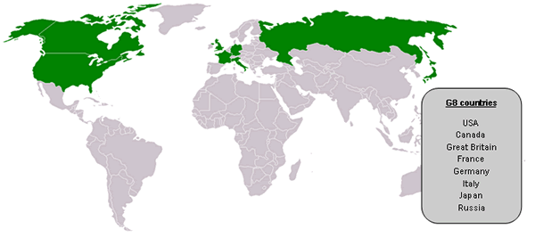

Words
- advantage = the good side of something
- age = period of history
- argument =reasons
- business = company
- cause =lead to
- cell phone = a mobile telephone
- close down = to stop producing goods
- connect = to link together
- create = make
- customer = a person who buys something
- debate = discussion
- develop =grow
- developed countries = rich , industrialized countries
- disease = illness
- distance =space
- economic =about the economy
- economy =the system of producing goods and products in a country and selling them
- educated = if you have gone to school and learned a lot
- environmental = everything that is about the air, water or land around us
- especially =above all, more than others
- exchange = to give someone something and get something else in return
- factory = building in which you produce goods
- farther =here: over greater distances
- firm = company
- focus on = concentrate on
- G8 = Group of 8 = the most important industrialized countries in the world
- goods = things that you produce and sell
- government =the people who rule a country
- however =but
- in favour of = for something
- investor = a person who gives money to a company and expects to get more money in return
- law = rules that a country has
- lead to =cause
- leader = the most powerful person of a country
- make sure = to check that something has been done
- merchant = someone who buys and sells goods
- pace = speed
- point out = to show
- produce = make
- pull out = take out
- reach = get to
- Silk Road = an old route on which silk was carried from Europe to Central Asia
- spread =to move from one place to another
- steam—powered =run by a steam engine ; power is produced by making water hot so that it turns into a gas
- steel = a strong metal that you can form
- strict =exact
- summit = meeting for powerful leaders of a country
- teleworker = someone who works from home and uses a computer, telephone etc..
- trade = to buy and sell goods
- unemployment = if you don’t have a job

